**MID-TERM EXAM(PHASE-1)**

OPEN SOURCE GRAOHICS & ANIMATION TOOLS

BACHELOR OF TECHNOLOGY

in

COMPUTER SCIENCE AND ENGINEERING

with specialization in ***Open Source and Open Standards***

Submitted by

**Student Name – Nakul Garg**

**Roll No - R100218032**

**SAP ID - 500069410**

Submitted to

***Dr. Durgansh Sharma***

***Assitant Professor,Department of Cybernetics***



**SCHOOL OF COMPUTER SCIENCE**

UNIVERSITY OF PETROLEUM & ENERGY STUDIES

Bidholi Campus, Energy Acres, Dehradun – 248007.

**Febuarary – 2020**

**TOPIC-SIZZLER POSTER**

**STEPS Involved in Executing Project:-**

INDEX OF STEPS

Step 1 3

Step 2 4

Step 3 5

Step 4 6

Step 5 6

Step 6 7

Step 7 7

Step 8 9

Informative Points:- 10

Step 1-First we have to design the background of poster so, import a textured png file in Gimp.

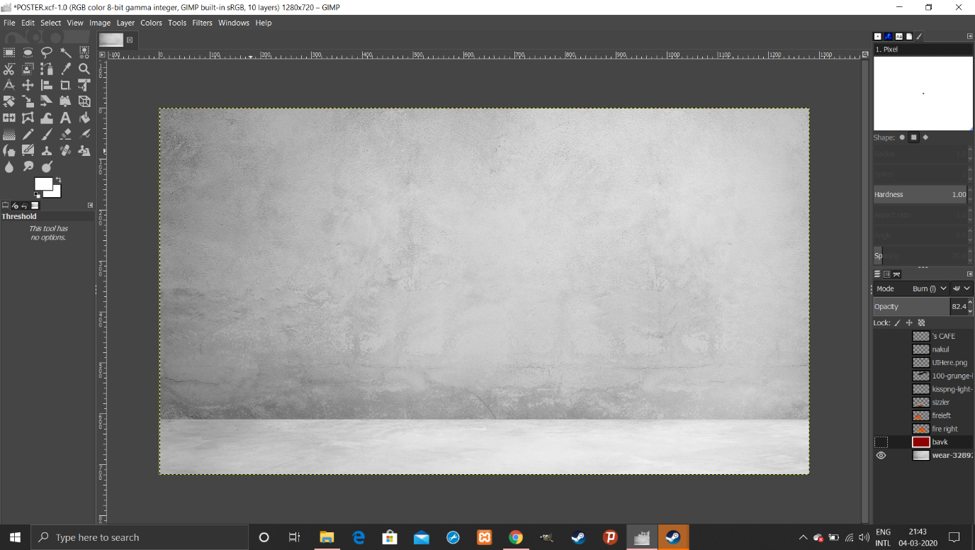

Step 2-Make this background more attractive by using the options in coloring tool such as „Threshold“.

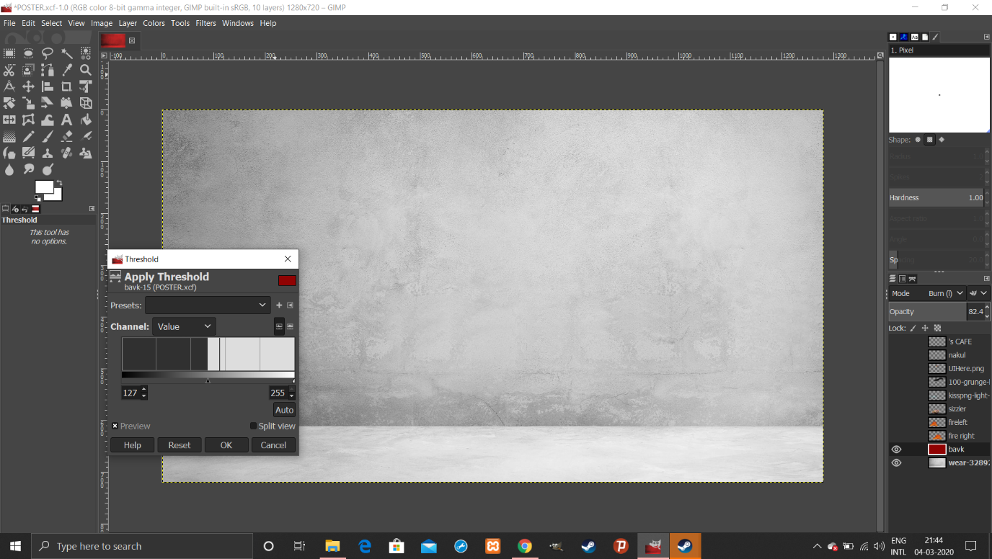

It will looks like this:-

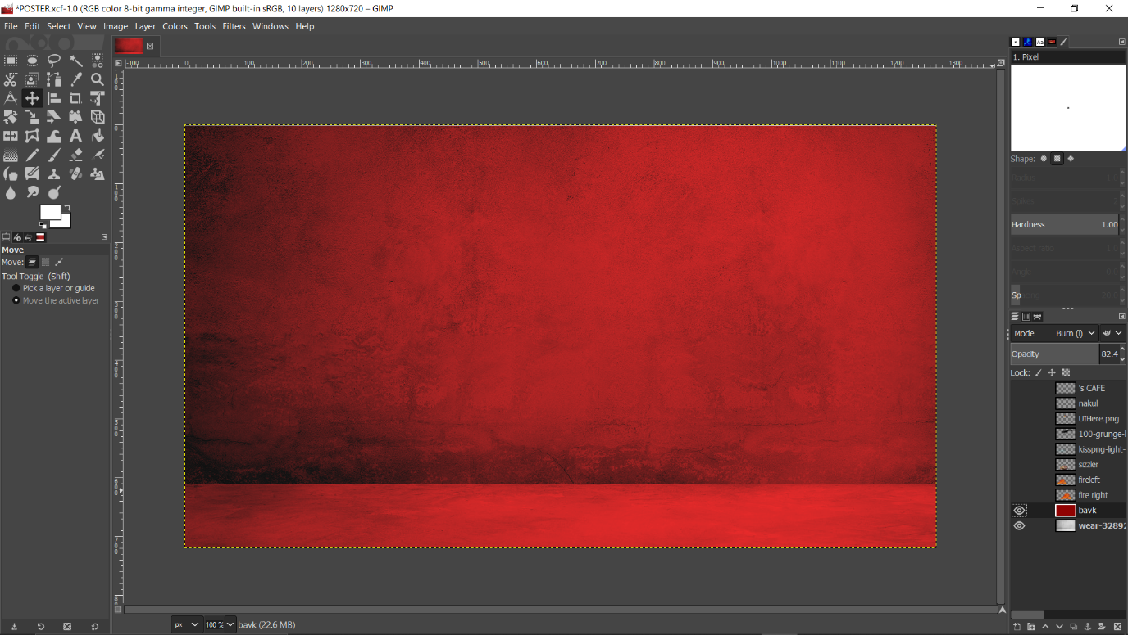

Step 3-Now import a beautiful Sizzler png file in new layer without background so that we can make poster more attractive by making different layers.

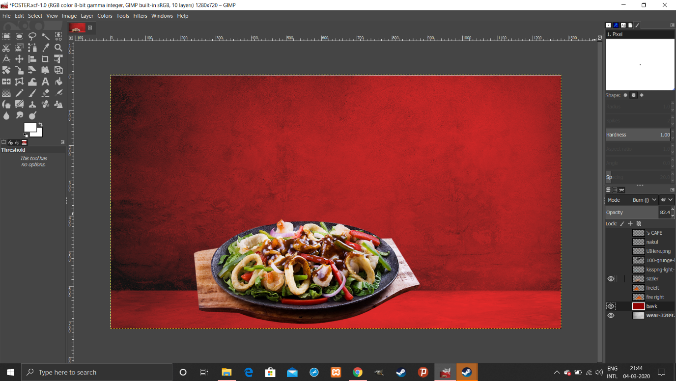

Step 4-Now make sizzler more sizzling by adding some fires in different layers.

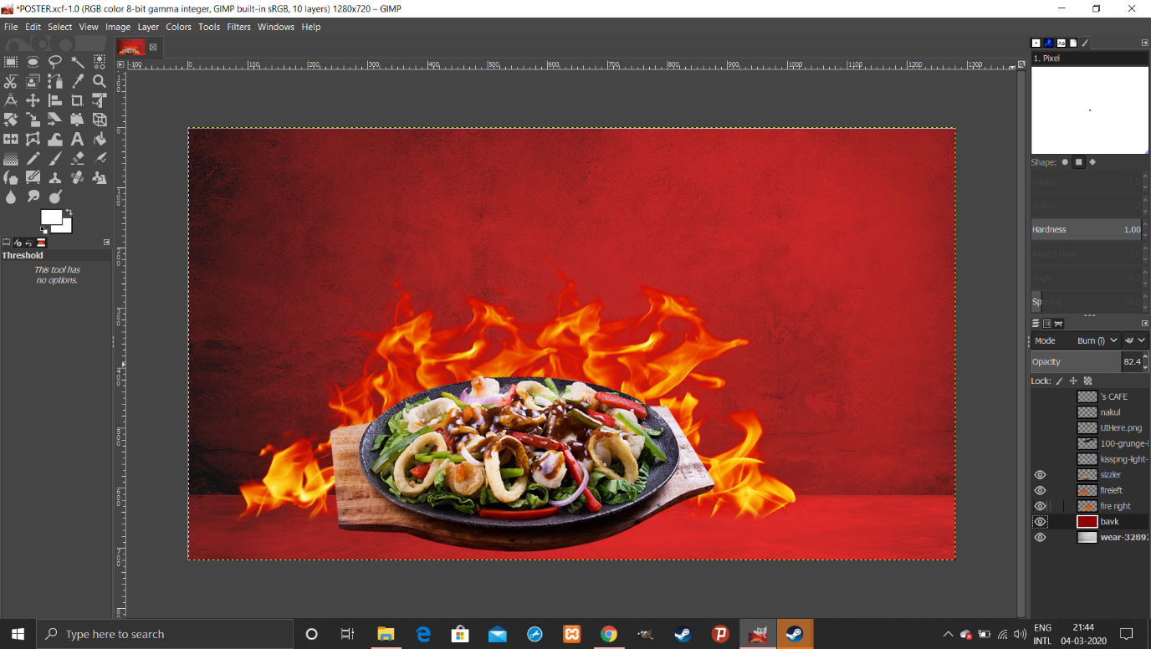

Step 5-Now make Sizzler more shiny by adding a shiny touch which can be imported through a pnf file in another layer.

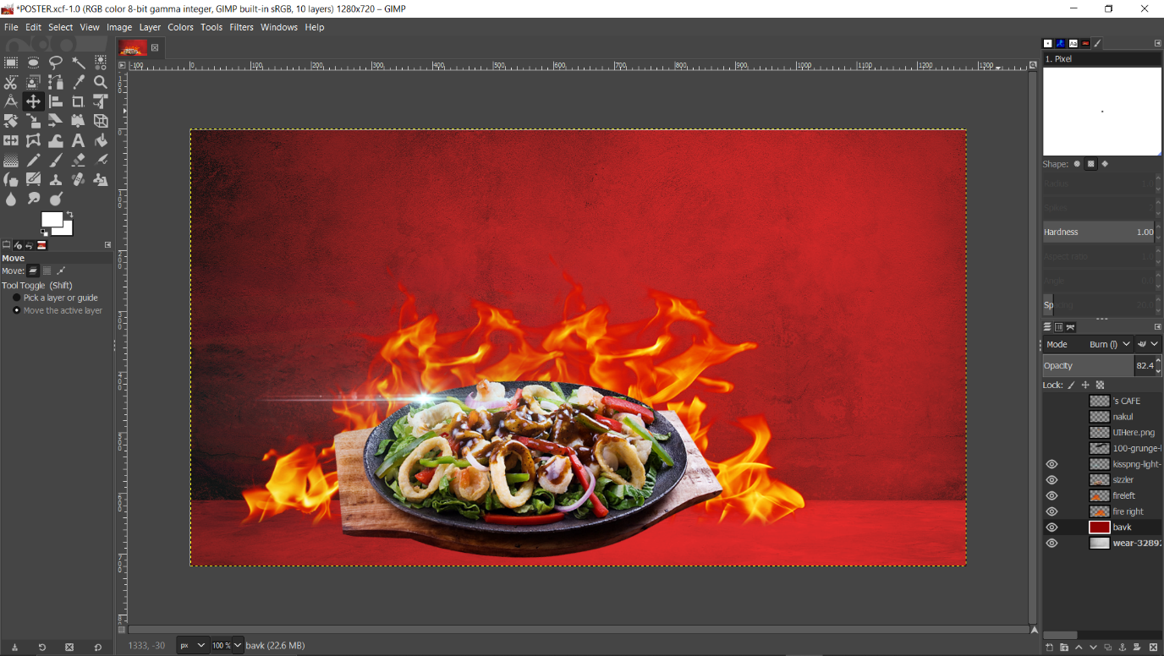

Step 6-Now make poster make more attractive by adding some saturation effects so that fire and sizzler can interact with each other.

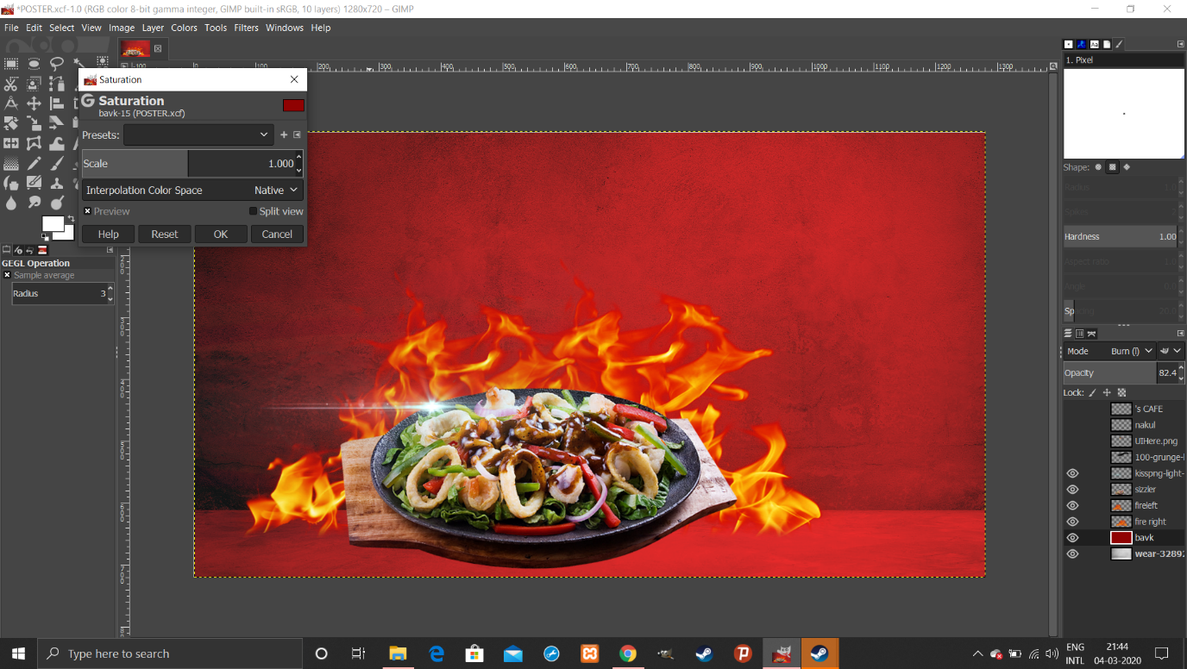

Step 7- Now here is the most important part of the poster which is text field, now for making poster making more unique I used both Hindi and English in different layers text.

Hindi Text-Downloaded(0Surrender)

English Text-Alex Brush

Size Used-100 PX

Kerning-7.0

Leading-0.1

Colour-White and Yellow

Hinting-Medium

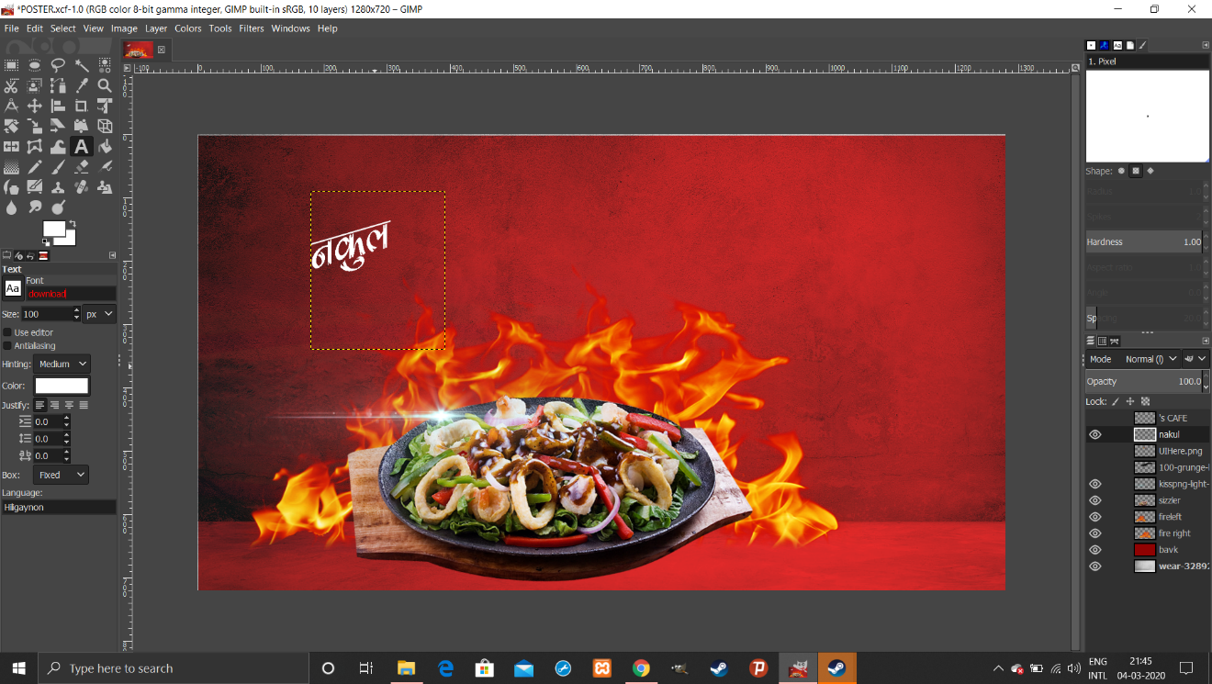

AND

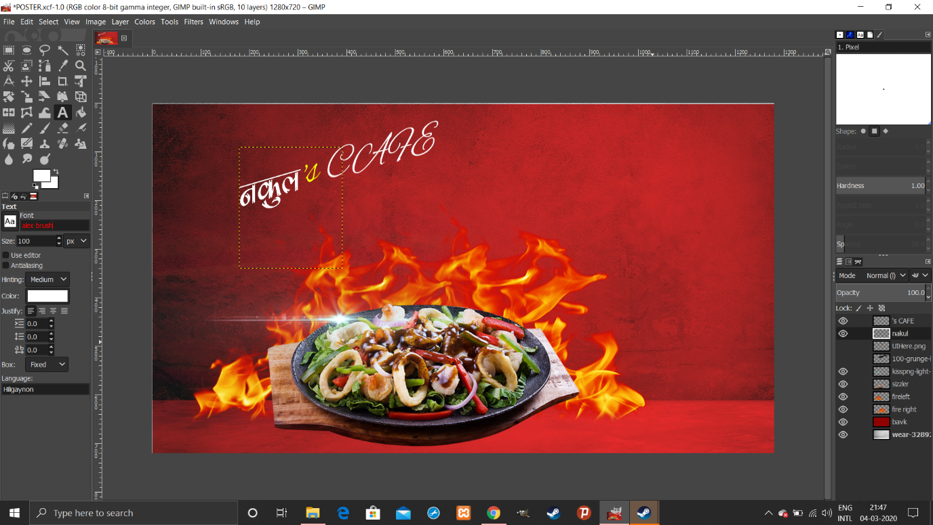

Step 8-Now we have to tell public what is this, means this is Sizzler so we have to introduce Sizzler word but I imported a unique png file of this word and making this word more attractive I used a black stroke in background by using two different layers.

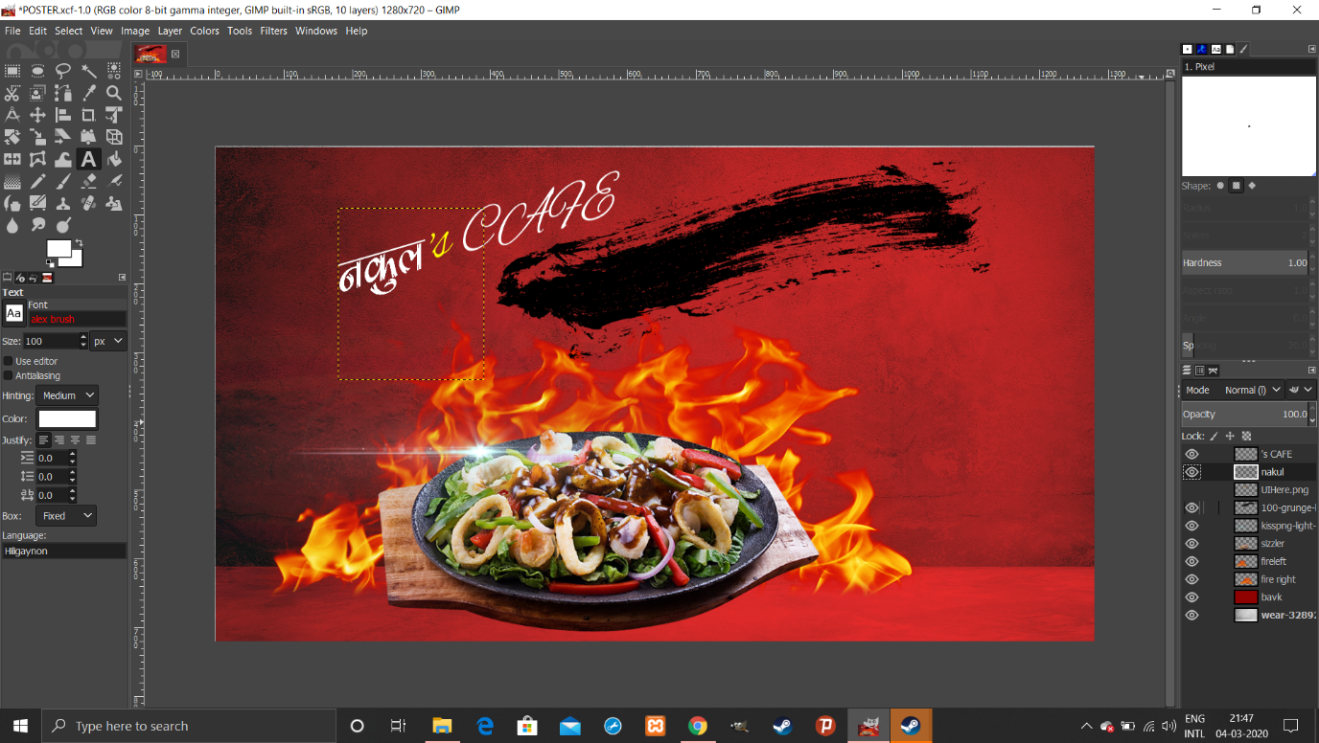

And Finally our Sizzler is ready to serve which is hot and sizzling.

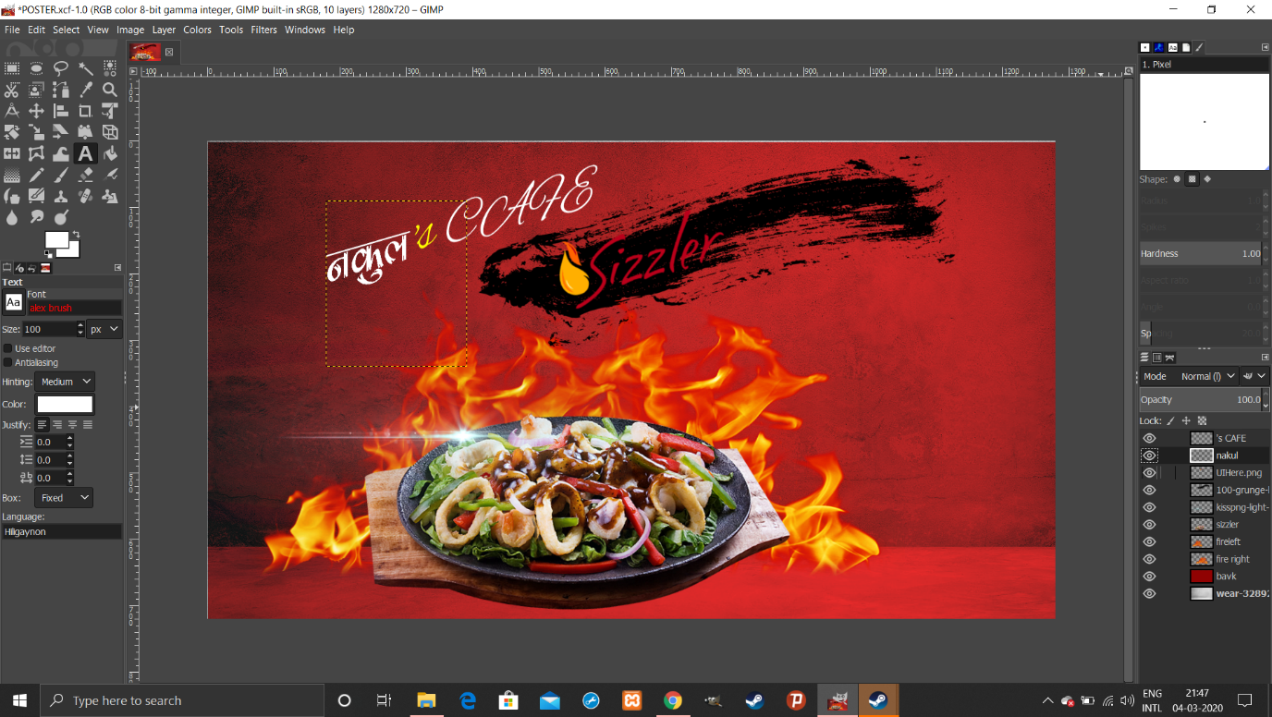

# 

# Informative Points:-

🡪Typography used is Hindi typography because of Indian culture It makes poster more unique and attractive.

🡪Colour used in background is red texture which is composed from saturation with grey so font colour is white and yellow as it looks more satisfying and realistic.

🡪 Channels R G B with an alpha channel A constitute all the layers in the project. These channels are give layer their body and color. These color channel apply to the whole final image as the three primary colors necessary to render every single color in the project.